Homework 1 - End-to-end Speech Recognition

學號：r05922130 系級： 資工所 姓名：王瀚磊

**1. (2%) Train a seq2seq attention-based ASR model. Paste the learning curve and alignment plot from tensorboard. Report the CER/WER of dev set and kaggle score of testing set.**

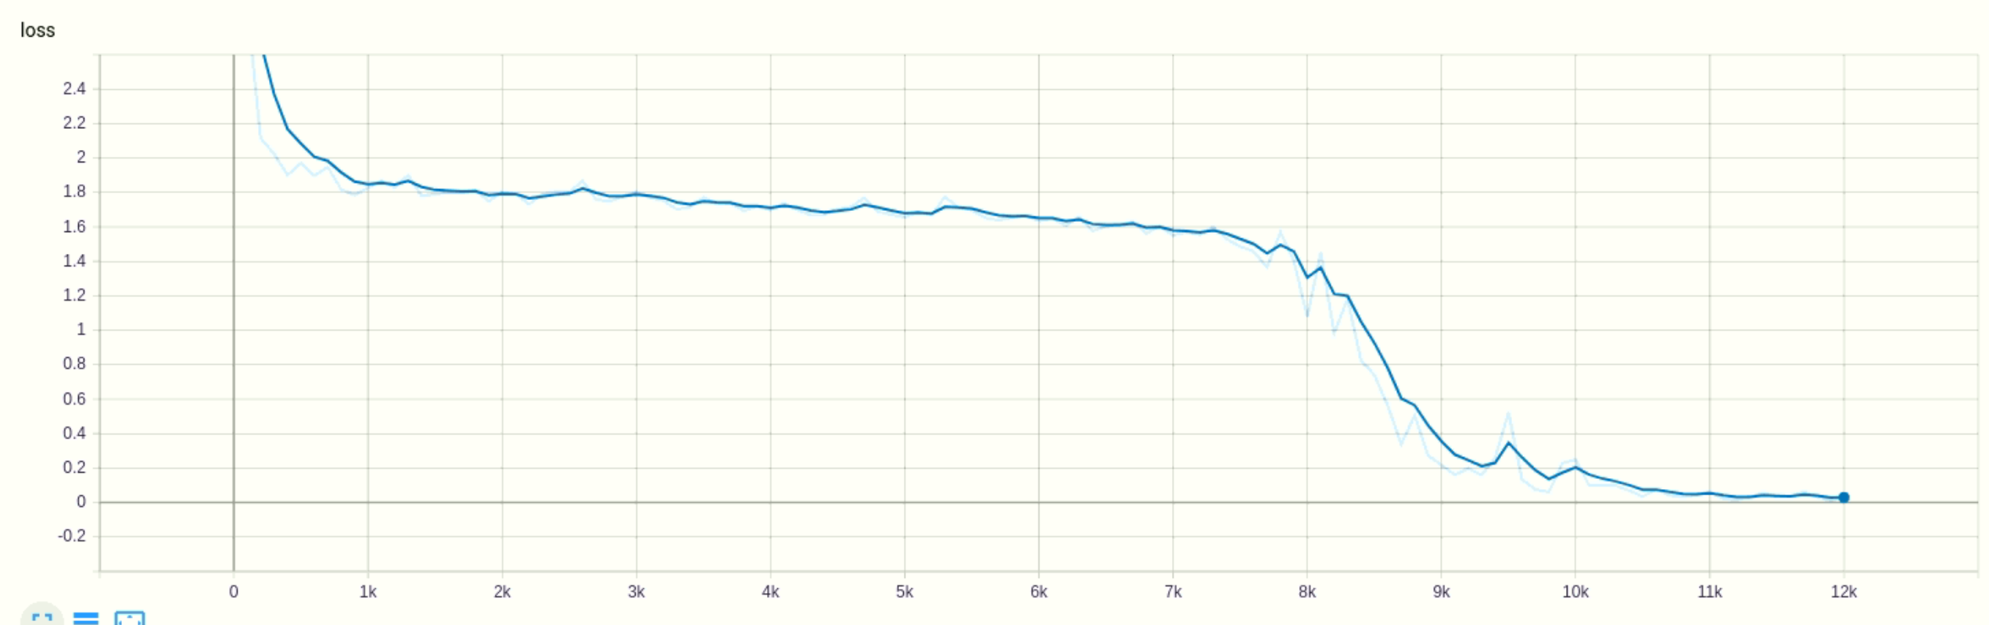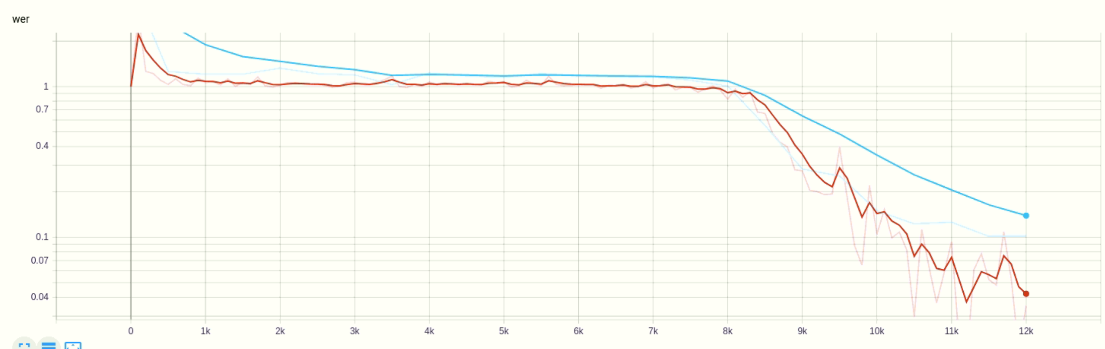

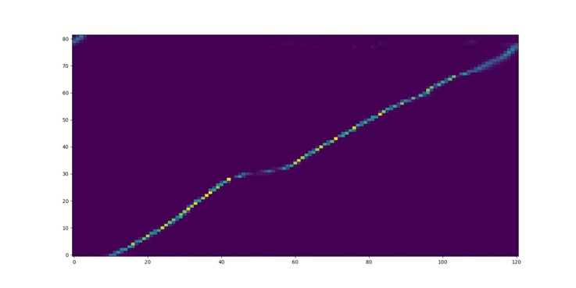

**2. (2%) Repeat 1. by training a joint CTC-attention ASR model (decoding with seq2seq decoder). Which model converges faster? Explain why.**

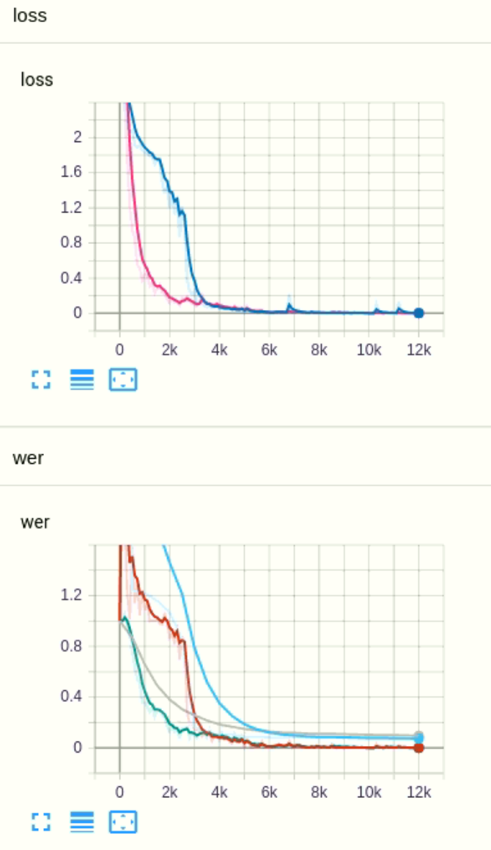

**多了一個ctc loss加速encoder收斂**

**3. (2%) Use the model in 2. to decode only in CTC (ctc_weight=1.0). Report the CER/WER of dev set and kaggle score of testing set. Which model performs better in 1. 2. 3.? Explain why.**

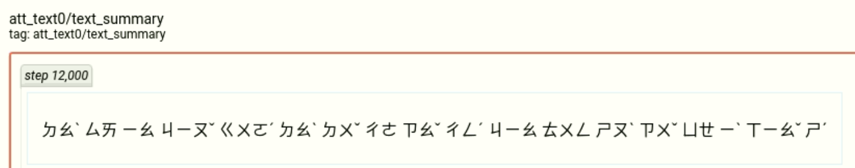

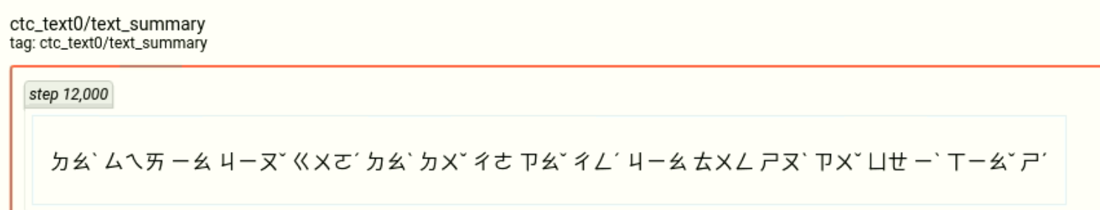

**4. (2%) Train an external language model. Use it to help the model in 1. to decode. Report the CER/WER of dev set and kaggle score of testing set.**

**5. (2%) Try decoding the model in 4. with different beam size (e.g. 2, 5, 10, 20, 50). Which beam size is the best?**

**Bonus: (1%)**